Use elif to list all of your condition, and use else to capture all others (errors)

Your else always ends up with error

In condition, when you try to justify the value in “condition”,,always use “==” double=

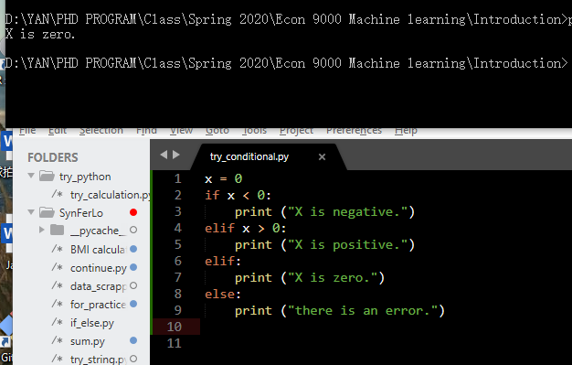

Use “int ()” when you want a precise integer,

“float ()” is kind of an approximation

Floating point comparison is never safe…USE INTEGER.

NEVER USE FLOATING NUMBER IN CONDITIOND, ESPECIALLY WHEN YOU TALK “EQUAL”.

Use math to compare:

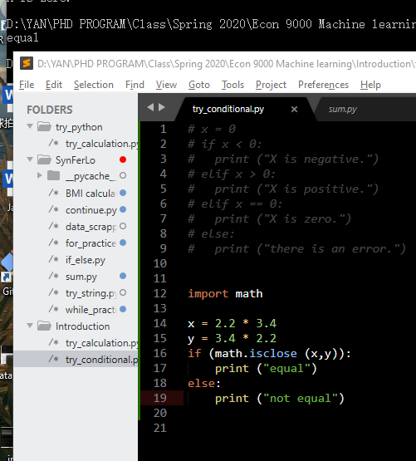

For…in

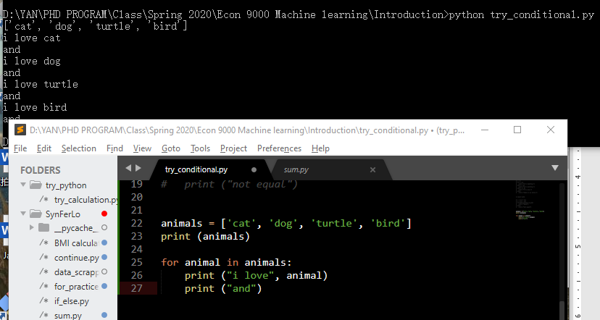

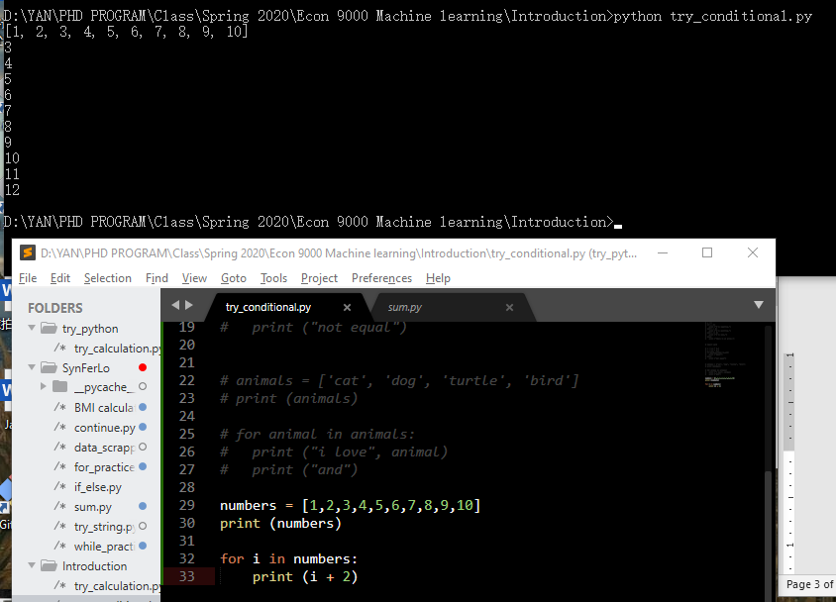

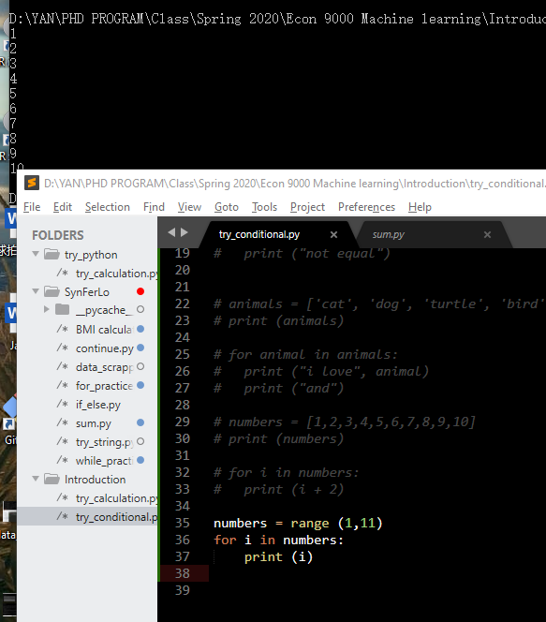

Loop, infinite loop

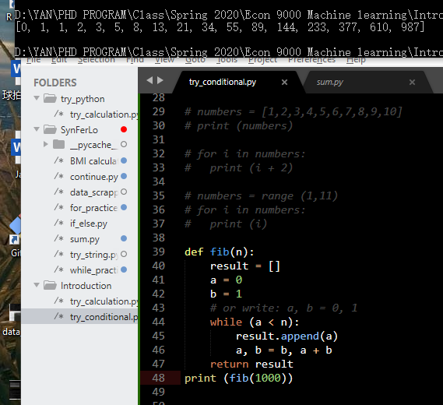

NUMPY:

Name format: package.function

Ie math.isclose; numpy.arange()

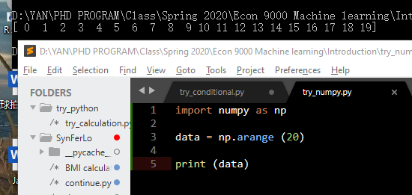

Command: reshape(row, col)

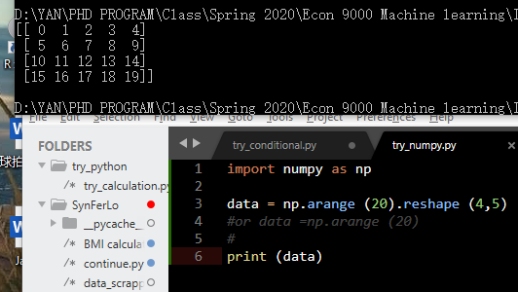

Note: sklearn is friendly to numpy, but not for pandas

使用pandas输出100天的日期

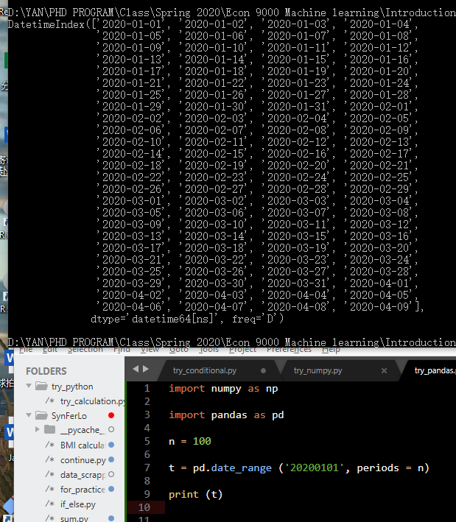

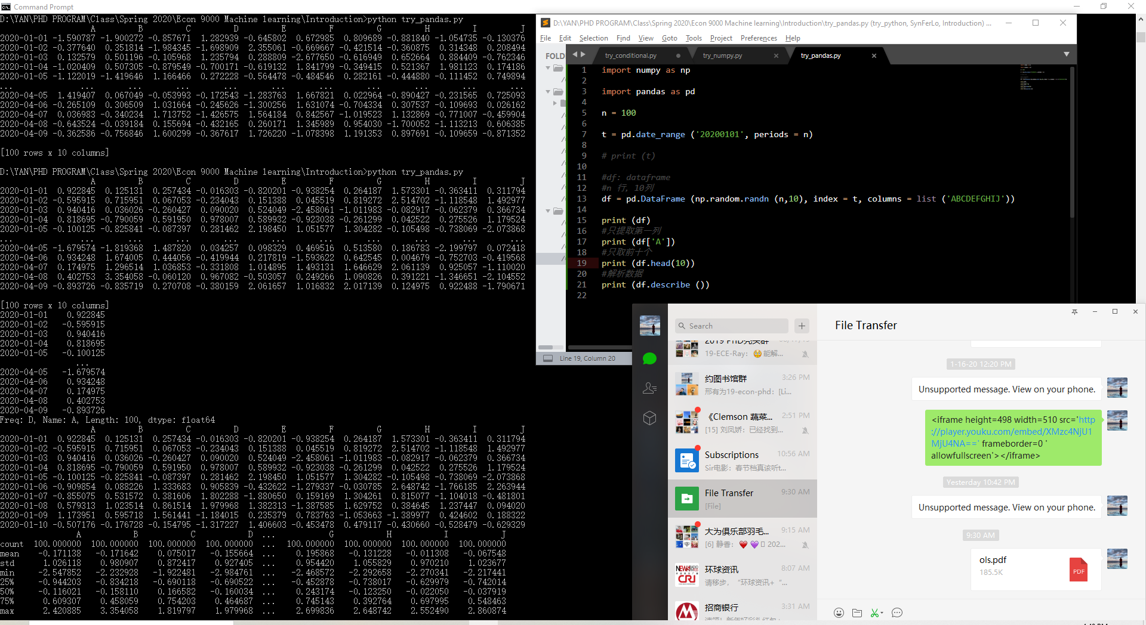

Only first three rows:

